12/04/2022
Student: Marcin Kaczmarek – C00242533
SUPERVISOR: RICHARD BUTLER - BSC (HONS), MSC, CISSP
Deepfake Detection Tool
Final Report

Acknowledgements

I'd want to convey my appreciation to my supervisor, Richard Butler, for his advice, comments, and continued support during the course of this project across the entire year. In addition, I would like to express my gratitude to all of my other lecturers, who have assisted me and offered valuable insight and guidance during the year, and who have contributed to my development as a professional individual.

Abstract

Problem:
If you live in the modern world, you have the ability to alter the format of any photo, video, or music file. Furthermore, there may be a variety of justifications or motivations for doing so.
From a simple desire to better one's looks to more severe objectives such as cheating or attempting to influence someone's perception or image of reality, there is something for everyone.
But how can you tell the difference between what is true and what is false? What tools should we employ, and can we be positive that the image we want to study is real or not using them, and with what degree of certainty can we decide this?
Is that even possible?
My project was just an attempt to develop a tool that, through suitable mathematical manipulations and the application of Benford's law, could be used to do many tasks. It analyses the image and does a comparison between the curve of Benford's law and the curve that was derived after looking at our image.
Any differences are easily identified by the investigator.

Objectives:
On the basis of this study, which is based on Benford's law and its frequency distributions, software that can determine if a picture is real or not is being developed.

Methods:
It is possible to assess whether or not a picture is real or false using Benford's Law, which is a mathematical equation.
It is based on the distribution of numbers within its range of action and on detecting whether or not the tested object conforms to the original distribution.

Contents
Acknowledgements 1
Abstract 1
Introduction 3
Deepfake 3
DEEPFAKES' ADVANTAGES 4
Deepfake testing characteristics 5
History 6
Prime Digit Law - Benford Law. 7
The Benford Law's Mathematical Explanation 8
Distribution of probabilities 10
Information and technical sciences 13
In the field of life sciences 13
Benford distribution properties 13
Benford set attributes 14
Application of the Benford Law 14
Detection of fraud 14
Mathematical models' accuracy 15
An examination of the 2009 Iranian elections. 15
Defending against deepfake 15
Deepstar 16
Resemblyzer 16
Image file formats 16
JPG File Format 16
PNG File Format 18
Formatted in GIFs 19
TIFF File Format 20
RAW File Format 21
Summary of the discussed image formats 22
The DCT 23
Compression of images 27
What Is Compression? 27
Compression methods for JPEG 28
Transformation process 28
Testing results 29
Technologies for the Project 37
Deepfake solutions as an alternative 38
Conclusion 38
Plagiarism Detection 39
Table of Figures 40
Table of Tables 40
References 41

Introduction

An extensive study has been undertaken in order to construct a deep fake image recognition algorithm. A deep fake is a modified image or video that pretends to illustrate a person's likeness but does not actually depict that individual in any way. Whatever the creator's intentions, this can be anything from a malicious programme to something as basic as a social media filter.
It is no longer possible to tell if images, video, or audio have been manipulated just by looking at them. There is no guarantee that commercial deep-fake detection tools will be able to tell the difference between an original and a fake.
I created a tool specifically for this task, based on Benford's prime number rule.
Images will lose their fine features as a result of compression, making it simpler for a bad individual to manipulate them, goes the thinking.

Deepfake

When combined with digital voice modulation, Deepfake is a technology that makes it possible to create characters that sound remarkably like the originals. Current artificial intelligence algorithms can create a nearly identical deep-fake hologram with only ONE photo and a 5-second audio sample.
(1) (Botticello, 2020)
There were the first Deepfakes in the porn industry around the end of 2017. For instance, an actor's physique was augmented with a digitally created celebrity's face. Consequently, we got a scene from a movie with a character who looked like a Hollywood model. But unfortunately, deepfake is becoming a much more severe problem, and battling it is more complex than ever.
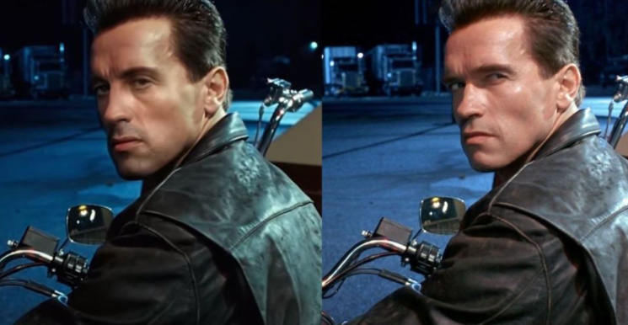
Figure 1- Deepfake Example

[2] (ScreenRant, 2020)
However, even if artificial intelligence has the capacity to transform the world, its misuse might be highly dangerous. In the case of "deepfake" propaganda operations, artificial intelligence algorithms may be used to influence groups, vilify individuals, and even determine the outcome of global elections or the commencement of a war, as has been demonstrated in previous cases.
True, deepfake does not just target politicians and celebrities, but they are not the only ones who fall prey to their schemes. Recent years have seen an increase in fraudsters' usage of the internet, who have utilised it to target high-profile organisations and influential individuals.

DEEPFAKES' ADVANTAGES

Bringing Your Loved Ones Back to Life!
Deepfakes have a great deal of potential use in the film business.
You have the ability to bring a deceased actor or actress back to life. Even if it is debatable from an ethical standpoint, it is doable and quite simple if we do not consider the implications of our actions. Furthermore, it is almost certainly far less expensive than alternative solutions.
More realistic scenes in films are being produced.
In order to change the physical attributes of the performers, you don't have to coerce them into doing things like shaving their heads, growing massive amounts of muscle, or losing tens of pounds that may be harmful to their health.

The Possibility of Obtaining a Formal Education
Imagine living in a world where you could attend physics lessons taught by Albert Einstein at your leisure, from anywhere in the globe! Deepfake makes the seemingly impossible feasible. It serves as a motivational tool for students to learn topics from its instructors. However, while it is possible to improve efficiency, there is still a long way to go.

Techniques for fending off Deepfake
Many applications can be used to combat and detect deepfake technology, including:

• FALdetector
• Deepstar
• Visual DeepFake Detection
• DeepFake Audio Detection
• Resemblyzer

[3] (PenTestIT, 2020)

However, they do not guarantee a 100% success rate.
Typically, they look at how an image changes when exposed to different lighting conditions or the finer points of facial expressions.
It's also possible to look at the multimedia files to see if they've been changed.
One of the most important factors is being aware of the potential dangers when it comes to technological safety. There are many different solutions in use, and we need to know what they are and how they work to be able to predict what might happen in the future. This way, we can protect ourselves more effectively and rationally from the risks of modern technology.

[4] (Yu et al., 2021)

Deepfake testing characteristics

1. Improper lighting can alter the colour of a person's face.
2. In photographs, the naked eye can discern some characters' skin tones and facial traits. False images may be detected by a lack of colour, poor lighting, and shading.
3. reducing the number of eye blinks.
4. Unnatural eye movements, a lack of or atypical blinking, or facial surroundings that don't fit the rest of the footage can all be spotted on video.
5. Human posture has an unnatural aspect.
6. Human posture and deformation can sometimes be observed unusually.
7. "Audio synchronisation" (if we speak about video files)
8. If the video conversion was done haphazardly, you might notice that the lip movements are not in time with the sound.
9. Incorrect positioning.
10. Some image edges may be fuzzy or unevenly textured. As shown by the pictures, there are some times when the proportions of the body parts don't seem right.
[5] (us.norton.com, n.d.)

Deepfake algorithms can't yet be detected with technologies that are 100 percent effective. Remediation measures include systems like Sherlock AI [6], which can detect irregularities in videos. Content makers can incorporate blockchain technology, or Natural Hash [7], into their source materials. Digital watermarks that can't be changed. [8]

[6] (DeepQuanty, n.d.)
[7] (Du, Chen and Ke, 2018)
(8) (Locklizard, 2015)

History

The Newcomb-Benford law, the Law of odd numbers, or the first digit law, are all variations of the Benford distribution.
While visiting the US Naval Observatory Library, Frank Newcomb noticed that the log table sheets were dirtier at the beginning and cleaner at the end. According to his findings, logarithmic array users are more inclined to search for numbers with lower digits at the beginning of their collections. In the American Journal of Mathematics, he wrote about his new idea. It was met with scepticism and quickly forgotten.
Unaware of Newcomb's work, Frank Benford made the same quality-based discovery in 1938: the wear of logarithmic tables' pages. After becoming intrigued by this phenomenon, Benford decided to investigate whether his theory might be discovered in other data sets, such as river surfaces, numbers written in newspapers, or even prices. Finally, in the Proceedings of the American Philosophical Society, he wrote a final essay about his research.
[9] (Gonsalves, 2020)
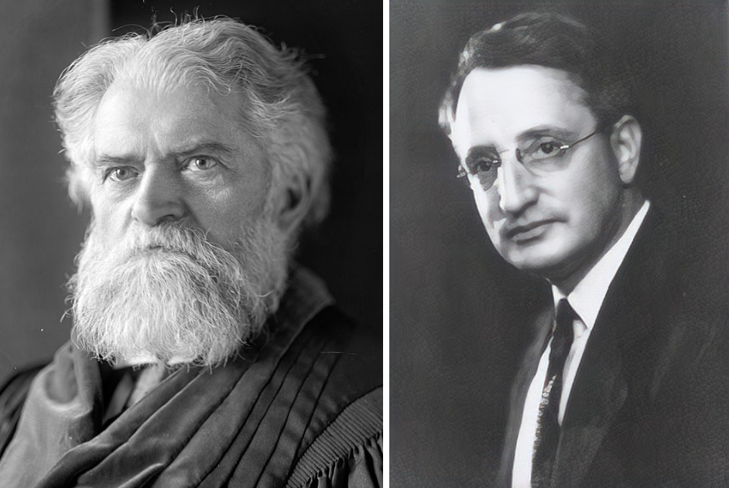

Figure 2- Simon Newcomb and Frank Benford

[9] (Gonsalves, 2020)

An anecdote.

Let me tell you a story that has nothing to do with this research topic.
Has anyone heard of Stigler's Law of Eponymy?
When it comes to making discoveries, this is relevant.
It is common to name discoveries after someone else, even if they did not make the discovery.
Introduced by the American statistician Stephen Stigler [10] in 1980, he said that no scientific discovery should be named after the person who made the discovery.
He also knew that Stigler's Law wasn't his idea. His predecessor, Robert Merton, came up with it first.
[10] (Gizmodo, n.d.)

Prime Digit Law - Benford Law.

Bills, river routes, election vote counts, and distances between cities all have something in common, and it's incredible how much we take for granted. There must be some sort of correlation between these supposedly unrelated data points. Also, how can I say they are related?
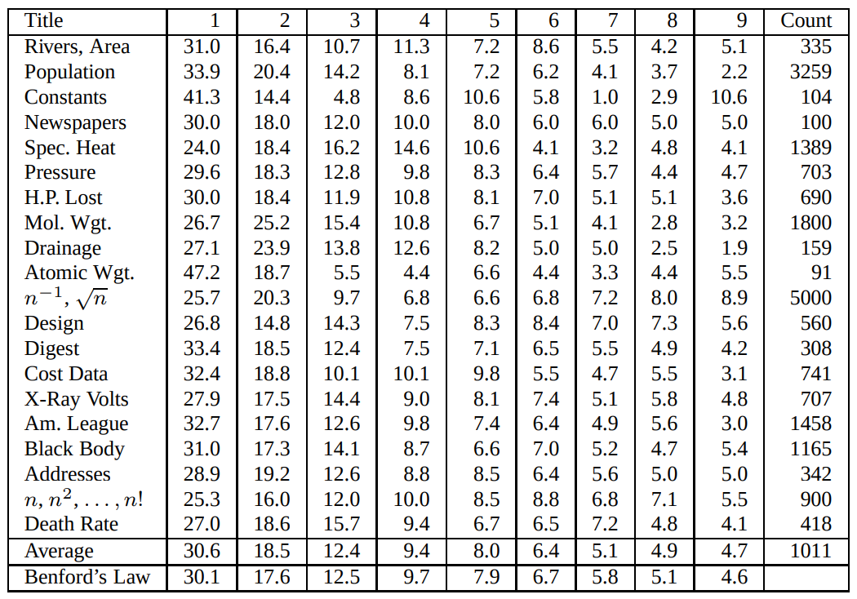

Table 1 Distribution of leading digits

[11] (Research & Development World, 2015)

Benford's theory was tested using a variety of datasets, as shown in the table above.
Benford's Law can be used for seemingly unrelated data sets that contain accurate data.
Using Benford's Law as a guide, the numbers in the last column at the bottom show the results of the calculations.

The Benford Law's Mathematical Explanation

Benford's Law, Benford Distribution, or the Law of First (Significant) Numbers, became known to the world. Moreover, the relationship illustrates how the discrete Benford distribution can be represented mathematically.
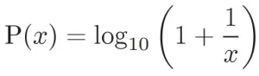

[12] (Labs, 2016)
• x is the leading digit.
• P (x) is the chance that x will be in the most important place in the digit.

Numbers are the building blocks of mathematics, and datasets are no exception.
What percentage of the time do we see the number "1" appear in a series of numbers?
Each of the digits from 1 to 9 is nothing more than a digit.
As a result, all of these figures should represent the same proportion of our harvest.

This is what I mean:
1 - 30.1%
2 - 17.6%
3 - 12.5%
4 - 9.7 %
.
.
9 - 4.6%, right?

Not!
Using Benford's method, these numbers are more likely to occur in a different order.
About 30% of the time, the number "1" appears, while only 5% of the time, the number "9" does.
It still begs the question, why?
Consider the following set of numbers: the distance from home to school.
Some distances are quite short:
1,2,3,4,5,6,7,8,9

Look at how many times we already have the number "1" in the initial position:1,2,3,4,5;6,7,8,9;10;11;12;13;14;15;16;17;18;19.

When it comes to large distances, we have a lot more numbers like 2, 3, 4, and so on: 21,22; 23,24; 31,32; 33; 34; 41; 42; 45.

We have many more "1" in front of large distances like 123,180,169.

So, keep in mind that the number "1" appears far more frequently than the other numbers 2, 3, 4, etc.

Although there is the same amount of information, it is shown at a smaller size when employing logs. Bedford does this by transforming his data into a scale he can deal with using logarithms. To put it simply, exponentiation and logarithms are inverted functions.
1,000 is the result of multiplying 10 by 4 times. To put it another way, the logarithm of 1,000 gives us 4. So, as a result, we'll get 5 from the log (10,000).
Because adding is the inverse of utilising a log, a large number can shrink a log.
For example, between 0 and 10, for example, you have a lot of data, but then you have a smaller amount of data from 2 to 100.
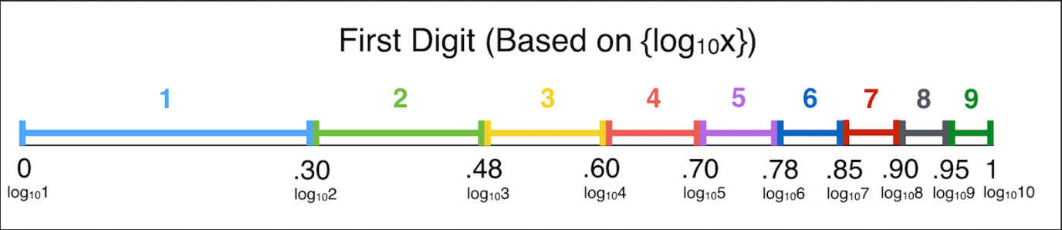
Figure 3- "Benford’s Law | Brilliant Math & Science Wiki”2019)

[40](“Benford’s Law | Brilliant Math & Science Wiki”2019)

Observe the similarities between Benford's Law and the Log Axis Scale. Frank recognises this and comes up with an equation to explain it, so he does.

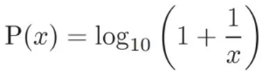

Or, to put it another way:

P = log(n + 1) – log(n)

Calculation:

P (1) = log10 (1 + 1/1)  = log10 (2)  = 0.30103  = 30.1 (rounded) | P (2) = log10 (1 + 1/2)  = log10 (1.5)  = 0.17609 ...  = 17.6% (rounded) | P (3) = log10 (1 + 1/3)  = log10 (1.33333)  = 0.124938  = 12.5% (rounded)

Distribution of probabilities
1 2 3 4 5 6 7 8 9
30.1% 17.6% 12.5% 9.7% 7.9% 6.7% 5.8% 5.1% 4.6%
The table below shows the approximate chance of each digit being in the most significant position.
Table 2 Benford Law Distribution
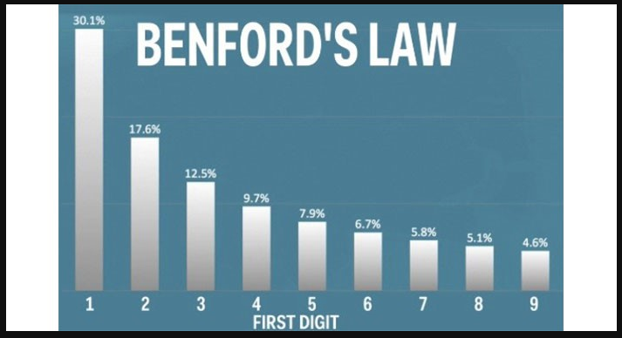

There are several uses for the Benford distribution. First, random number generators are unaware that specific numbers appear more frequently in the first slot than others.
For the 2nd through 3rd digits, Benford extended his Law.
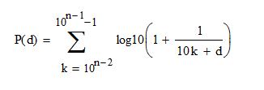

•d – is any digit from 1 to 9
•k – is a position of the digit
[13] (Invest Excel, 2012)
The results of his computations are shown in the following table:
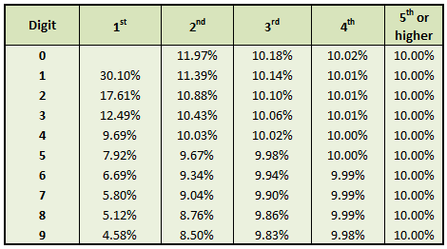
Table 3 The digit frequency predicted by the equation

[13] (Invest Excel, 2012)

Using Benford's Law, you may trace a company's finances (for example, expenses) and establish if they are authentic and have not been manipulated [14].

• Analysing data with the help of Benford distributions
• Benford Distribution is a method for detecting financial crime.
• Recognising tax fraud, detecting erroneous or misleading accounting
• In-depth research of stock market data [14]
[14] (Anon, n.d.)
Benford's Law has been utilised in various ways to regulate stock trading and investment outcomes. [15] The SEC, for example, uses Benford's Law as a tool to uncover financial statement distortions and inaccuracies (The State Examinations Commission).
[15] (Amiram, Bozanic and Rouen, 2015)

A study of online auction pricing.
You can verify the legitimacy of online auctions by referring to this law.
Auctions can be confirmed as fair or controlled, depending on your evidence.
[7] (Du, Chen and Ke, 2018)

Information and technical sciences

Acknowledgement of the digitally saved photos' validity and authentication.
My project's purpose is to identify fake and modified images.
[7] (Du, Chen and Ke, 2018)

In the field of life sciences

In drug efficacy studies, we can apply Benford's Law to verify the authenticity and avoid mistakes.

• To verify the integrity of pollutant levels messages
• Do additional testing on real datasets.
• And there are plenty of other examples.
• Evaluating the efficacy of medicines
[7] (Du, Chen and Ke, 2018)

Benford distribution properties

Benford's Law does not apply to all large, natural (i.e., unmanipulated) datasets. The observation result must meet several preconditions before it can be considered reliable.
There are a few things to keep in mind while applying Benford's Law to our research.
How well-suited is the tested dataset to the purpose of the experiment?
Another consideration is which tests should be performed and how the results should be interpreted.
[16] (Durtschi, Hillison and Pacini, n.d.)

If you look at accounting data, for example, the Benford distribution is supposed to be used a lot.
This happens when numbers are connected and, more precisely, when calculations provide certain conclusions.
• There must be only one dataset for all of the data.
• One dataset is required for testing purposes. [16]
• The dataset must be limitless to take into account all of the possible.
Identifiers, phone numbers, and (artificially produced) bank accounts that violate Benford's Law should not be included in datasets. [16]
Data from retail sales or river lengths, for example, should have lower-value figures than higher-value ones. [16]
[16] (Durtschi, Hillison and Pacini, n.d.)

Benford set attributes

It is possible to create a new Benford set by multiplying all of the values in our Benford set by a constant number. [17]
Base invariance, Benford's Law, is universal.
All mathematical operations, such as addition and subtraction, exponentiation, multiplication, or division of sets, generate another Benford set, proving the set's authenticity. [17]
[17] (Browne, 1998)

Application of the Benford Law

Detection of fraud

The fraud of $ 1,878,687.58 in the Arizona municipality of Wayne by James Nelson, found guilty in 1992, is a prime example.
He was able to do so by issuing 23 phoney checks. The fraud began with a tiny amount of fake reviews, and then the number of fake reviews grew over time. The vast majority of the cheques were for less than $1 million. "

Because the first digits of the individual sums were broken down, it was easy to identify the crime.
One of the first tests used in fraud detection was the Benford Law Test. [20]
[18] (Invest Excel, 2012b)
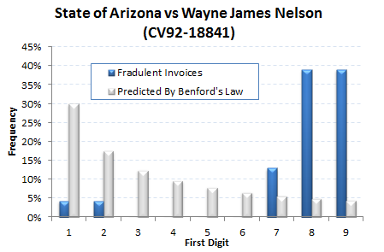

Table 4 Accounting fraud example [18] (Invest Excel, 2012b)

Mathematical models' accuracy

Models of population change, for example, use Benford's rule to verify the accuracy of mathematical descriptions of data evolution. Consequently, with data that matches Benford's Law, we should expect output according to this connection. Otherwise, the "natural" data distribution has been messed up by the model (algorithm) applied.

An examination of the 2009 Iranian elections.

The Nicolaus Copernicus University in Poland's Boudewijn Roukema took a closer look at the recent elections.
When he compared Benford's Law to voting patterns in different parts of the world, he found that there were some differences.
The incumbent president and the current winner got a lot of votes in three of the six most populous states.
A massive impact on Iran's election results could have been had. [19]
[19] (Roukema, 2013)

Defending against deepfake

Anti-Deepfake technology may be the best solution. For instance,
1. Detection methods for deepfake
2. Authentication of the content
3. Preventing the use of content to make Deepfakes. [20]
It isn't easy to verify the content due to users' large file volumes.
For technology, going through all of the published material in a short period is a huge problem.
Developing anti-deepfake technology isn't going to suffice. A government in any country may have views on how to control the usage of deepfake. Organisations must also use these technologies. [20]
[20] (Westerlund, 2019)
Various commercial deepfake detection tools, FALdetector:
It was made in Python to help find faces that have been changed in Photoshop.
It uses Photoshop software programmes to generate fake photographs of people's faces, which are then used to train a fully trained model. [21]
Image distortion applied to a face emphasises this software, which is designed to work with Photoshop. It is a well-known and widely practised facial alteration.
While classifying and predicting whether or not the face has changed, this software also seeks to locate any possible modifications and implement a system that can undo them. [21]
[21] (Anon, n.d.)

Deepstar

Deepstar is a Python-based open source toolbox for detecting deepfake films using artificial intelligence.
Anti-counterfeit detection methods range from looking at the lips of an object to seeing if it has been changed in a video.
Thanks to this method, there's a high degree of certainty that the character being analysed has been modified. [22]
[22] (PenTestIT, 2020a)

Resemblyzer

A speech encoder and a deep learning model are used in the Resemblyzer.
It comes up with a full description of the voice's traits based on the 256 values that make up the human voice.
It is ideal for various purposes, including authenticating who is speaking and whether or not their voice has been altered. [23]
[23] (Jemine, n.d.)

Image file formats

A suitable and valuable file format must be chosen to implement the project.
JPEG, GIF, PNG, and TIFF are the most commonly used formats for saving photographs. Each one has its own set of benefits.

JPG File Format

The most well-known image format is JPG, short for Joint Photographic Experts Group. As a result of the display's nearly limitless colour range, it is the default setting for most images stored. [24]
[24] (Iqbal, 2019)
In addition, JPG allows you to select a compression level from 0% to 100%, ranging from the most compressed to the least compressed (no compression). 60% to 70% is the most common range for designers. Image quality isn't affected, but the file size is significantly reduced. [24]
As a result, the original data is lost when JPG is compressed. As a result, a photo will degrade further each time it is saved and exported as a JPG file.
Photographs, photography, and other visual media with many colours are frequently stored in the JPG file format. [25]
[25] (Rishab2612, 2016)
The Advantages of Using JPEG Images
• High-quality photography and videography
• Reducing the file size is a snap.
• consistently displayed in email clients.
Negative JPEGs
• There is no transparency in this situation.
• To provide a cluttered appearance to the text
• 'No animation'
• There is no requirement that search-related automated metadata contain any information.
[24] (Iqbal, 2019)
[25] (Rishab2612, 2016)

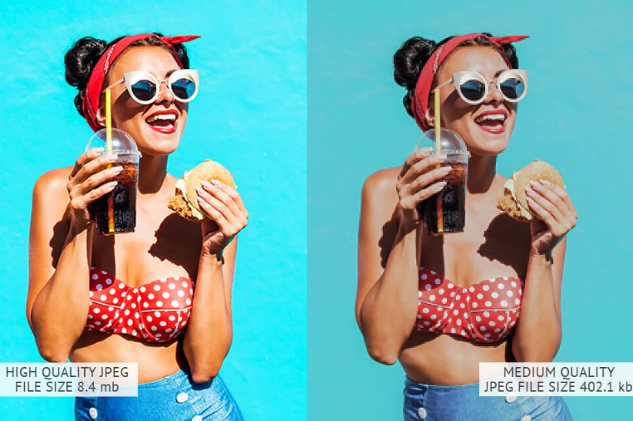
Figure 4- JPEG example image

[26] (FixThePhoto.com, n.d.)
Using JPEG compression, images can be reduced in size to take up less storage space. Loss of visual quality is a drawback of compression. JPEG compression removes some pixels each time a photo is compressed, and the process is irreversible. [27]

[27] (DISCRETE COSINE TRANSFORM DISCRETE COSINE TRANSFORM FOR VARIOUS VALUES OF U AND V, n.d.)

Our deepfake file research will be significantly aided by this information.

PNG File Format

Transparency is a feature of PNG that JPG does not have.
There are a lot of different image formats on the Internet, but PNG (Portable Network Graphics) is one of the most common.
PNG is so popular because it can be used to include logos and other design elements on websites.
PNG-8 and PNG-24 are two different forms of PNG files. PNG-8 provides somewhat improved transparency and exports smaller but has a more limited colour palette (only 256 colours). PNG-24 exports at a bigger size but has an unlimited colour palette and transparency. There is no compression loss in either type of PNG. [28]
Unlike GIF files, which can contain motion, PNG files do not. So, icons, small photos, and other images that need to be transparent are the most common types of this file type.
[28] (W3.org, 2019)
PNG is a benefit.
• It is in favour of openness.
• perfect for photographs that include text.
• The PNG format is excellent for displaying logos.
• It contains a search engine-friendly description in the embedded text.
• PNG-8 is the smallest and lightest of the standard image formats.
• Smooth-edged exported goods
Negatives in PNG format
• Large files, such as photos, cause file sizes to balloon.
• They may not be rendered correctly by some older email clients.
• 'No animation'
• PNG-24 files can be large, making them unsuitable for sharing over the internet.
[28] (W3.org, 2019)
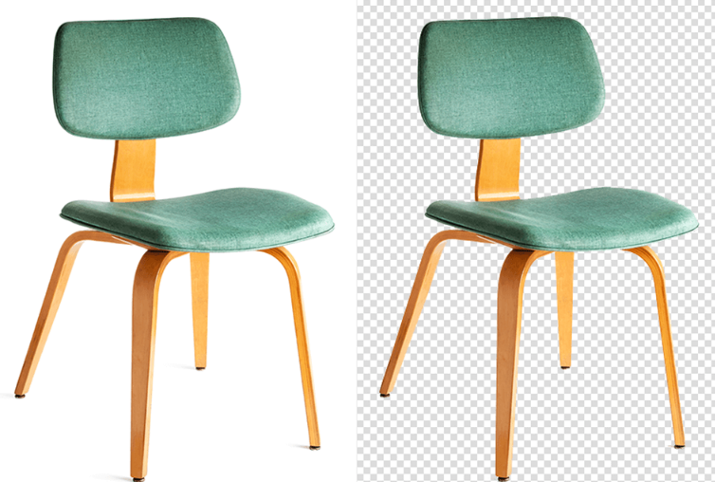

Figure 5 - PNG example image

[26] (FixThePhoto.com, n.d.)

Formatted in GIFs

An image format, GIF, or Graphical Interchange Format (GIF), compresses images significantly.
Each pixel in a GIF image can have up to 8 bits and 256 colours. In contrast to JPEG, which can only show up to 8 million colours, these pictures can show up to 16 million colours and go beyond the limits of the human eye.
All of the images or frames in the GIF file are combined to create an animated clip or short film. [29]
File Format: GIF
GIF files have a fixed-size graphic region that can be filled with one or several images. To create an animated GIF, the graphical area or fixed-size blocks in some GIF files can be divided up into sub-pictures. Bitmap data is stored in GIF files with a pixel depth ranging from one to eight bits. The photos are always saved with the RGB colour model and palette data. [29]

The Benefits of Animated GIF Images
• This is a small file.
• Excellent-Looking Photos
• Send Messages More Effectively
Negative animated GIFs
• Strictly Limited Colour Scheme
• There Is No Way to Edit.
• The quality of your internet connection is vital.
[29] (Ayres, 2017)
Figure 6 - GIF example image

[26] (FixThePhoto.com, n.d.)

To see, please click this link:
https://i.pinimg.com/originals/aa/18/c2/aa18c28f148884017b56e3e3e61f6e71.gif

TIFF File Format

TIFF, or TIF, stands for "Tagged Image File Format" and is used to store digital images.
Photographic and print data can be sent using TIFF, a standard format. A TIFF file contains raster data for all objects, including vectors and text. [30]
If you don't have vector data, you can use "Raster Data" to represent your 2D visual data. When dealing with raster data, the resolution is typically defined by the number of pixels or dots per inch present.
The TIFF format supports both RBG and CMYK colour spaces. An appropriate structure for RAW conversion supports up to 16-bit colour depth per colour channel. [30]
The Benefits of TIFF
• Compression without loss
• In terms of image quality,
• Perfect for printing out photos.
• Transparencies and layers are two terms used to describe them.
Negatives from the TIFF
• With too many browsers, this app does not work.
• This requires a more significant amount of space to store.

[30] (Iqbal, 2019b)
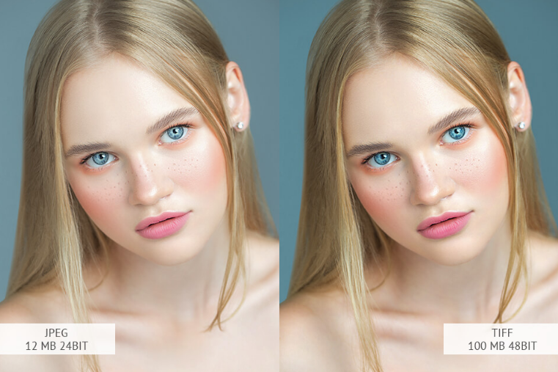
Figure 7 - TIFF example image
[26] (FixThePhoto.com, n.d.)

RAW File Format

Colour, white balance, and exposure information are stored in RAW format, unique to cameras and scanners. This information is helpful in photo editing, allowing you to produce the highest-quality images possible. [31]
Many memory cards and software like Photoshop and Lightroom are required before RAW images may be used. This, on the other hand, gives you flawless image quality and equivalent editing capabilities. [31]
RAW benefits
• The best possible image
• Exceptional photo retouching abilities
RAW negatives
• Relevant resources, such as storage space, software, and processing time, are required.

[31] (dpbestflow.org, n.d.)
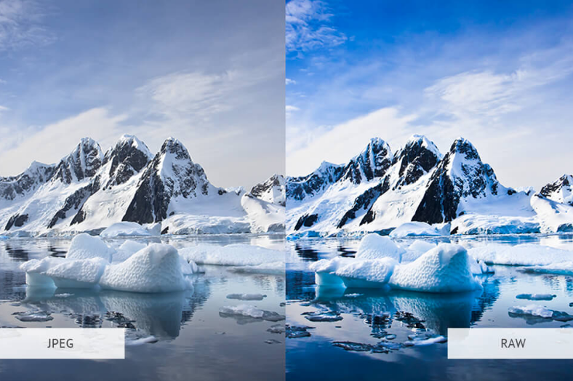
Figure 8 - RAW example image

[26] (FixThePhoto.com, n.d.)

Summary of the discussed image formats

 | JPG | TIFF | PNG | GIF | RAW
Lossless Compression | YES | YES | YES | YES | YES
Lossy Compression | YES | YES | YES | YES | YES
Transparency Support | NO | YES | YES | NO | NO
File size per 4K frame, RGB | 4 MB | 27 M.B. | 10.5 MB | 24MB | 9 MB
Support for 4K | YES | YES | YES | YES | YES
Maximum Supported bit depth | 12 | 32 | 8 | 8 | 32
Support for floating-point math | NO | YES | YES | NO | NO
Table 5 A Summary of Image Formats

For my project, JPEG was the most helpful format.
After careful consideration, I settled on the JPEG format as the most useful and practical image format for the project. [32]
JPEG is one of the most commonly used photo formats in the modern world. Consequently, a valuable source of information can also be found in this style. The technical JPEG markers can then be used to look for counterfeiting at the very core of the system.
As a result, these tags (metadata) include information about how the image was processed, what devices or software were used to alter it, what settings were employed, and more. The quality of a JPEG image is unaffected by several compression stages. Although this can be a negative feature, it can also be used to tell how many times a file has been compressed and by how much.

The DCT

The DCT (Discrete Cosine Transform) is the foundation of JPEG. [32]

Splitting an image into several frequency portions is done using DCT. The minor fundamental frequencies are the first to be filtered out of consideration. The image's critical frequencies are preserved to utilise the decompression process.

The reconstructed image may have some imperfections.
[32] (unix4lyfe.org, n.d.)

What is the DCT, and how does it works?

An initial value is transformed into a series of data points using the discrete cosine transform. This transform is extensively used in digital television and radio and partial differential equations. Jpeg compresses pictures rapidly and efficiently using DCT.
DCT is a critical component of the detection process in this project.
There are eight different levels of the DCT.
However, research will focus on DCT-II because JPEG employs it.
Due to this calculation, we will get a matrix with actual values matching the average values and the frequency of changes in the block. [34}
[34] (Scribd, n.d.)

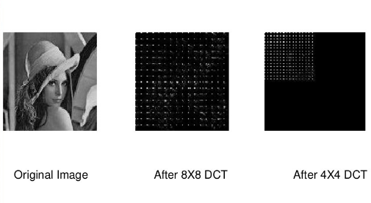

Figure 9 - Compression steps

The DCT is used to change the data to enhance the image's content. It is possible to code the correlation coefficients once the analysis has been carried out.
DCT, as previously said, eliminates unneeded data. [34]
[34] (Scribd, n.d.)
Here, we already have a cosine transform of the data block that goes through quantisation, removing non-existent data from an image quality standpoint.
The quantisation matrix is now composed of the values quantisation yielded.
Many of the rounded values will be zero, which means that the compressed image's size will be smaller when the rounded discounts are applied. [34]

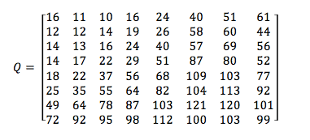

Figure 10 - 8x8 matrix [34]
[34] (Scribd, n.d.)

The data must now be cleaned and organised before it can be encoded.
To do this, we use the zig-zag algorithm shown below to transform our matrix.
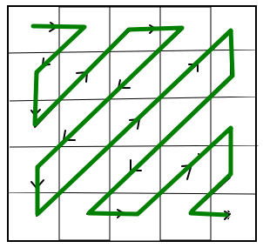

Figure 11 - Zig-Zag method [35]
The final phase is entropy coding, in which words – codes – replace the most prevalent elements.
A stream of binary data is what we get at the end of the process.
In many cases, quantisation yields a coefficient of 0 that may be successfully removed, resulting in compression. [35]
[35] (M, 2016)

DCT and quantisation process example:

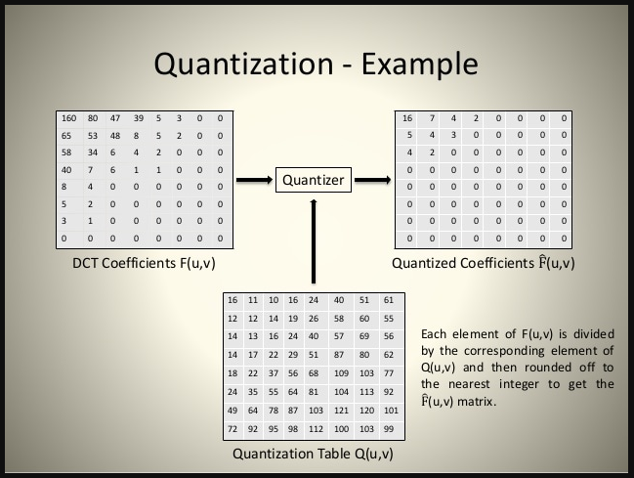

Figure 12 - DCT Quantization [ 35]

[35] (M, 2016)

Here we have an original model, a luminance-chrominance model.
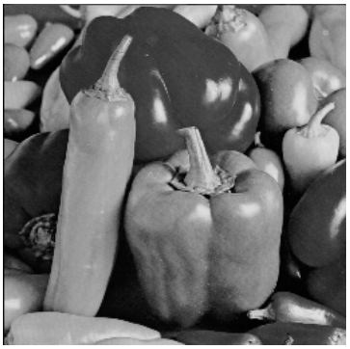
Figure 13 - Original picture example [36]
and here, after DCT processing:

Figure 14 - Picture during DCT processing [36]

Each block 8x8 is quantised using a quantisation matrix, and its size is reduced.

Figure 15 - Quantised DCT of the picture. [36]
Figure 16 - Original and processed image [37]

[37] (Syed and Khayam, 2003)

Compression of images

What Is Compression?

The Joint Photographic Experts Group (JPEG) began experimenting with several methods of JPEG compression in 1986 and continued doing so throughout the 1980s. Compression in JPEG is helpful for a variety of reasons. Since high-resolution photographs are becoming more affordable, their size also increases, resulting in storage concerns.
Compression reduces the amount of information in it to lower the size of a digital image.
If we wish to alter the image and perform professional processing, this data is helpful. If we don't need them, they can be erased without affecting the image quality. [33]
Compression speeds up the transmission of images while simultaneously reducing the amount of disc space required to store them.
An array of photographs is converted into a data set, which I'll be doing for my project to test the originality of those images. [33]
Decompression, on the other hand, refers to putting a picture back into its original format after it has been compressed.
[33] (Rishab2612, 2016b)

Compression methods for JPEG

JPEG compression is the key to verifying an image because it uses DCT, which uses cosine functions to find its data. A DCT is used to find the data in an image. Quality "Q" will go down as a picture is more compressed, making it look bad (100 meaning full quality). Having a lower number of 1's JPEG isn't a topic in my field, so I found it hard to understand. This is because image processing isn't a topic in my area.
The JPEG encoding procedure
Image verification relies on JPEG compression and DCT (cosine functions) to recover the data.
Algorithms can be employed to achieve this goal, but they all follow the same methodological framework.
Our image undergoes a metamorphosis at the beginning: the removal of unneeded information.
The following step is quantisation, which allows for the loss of specific data while retaining the necessary ones, resulting in our image's best possible quality. [33]
The use of entropy coding to further reduce the size of images is the next logical step after applying various techniques. Entropy coding involves transforming input data into a prefix code word of a variable length. [33]
[33] (Rishab2612, 2016b)

Transformation process

1.The first step is to transform the colours into the luminance-chrominance model.
If the saved image is in RGB format, each part is in the range of numbers.
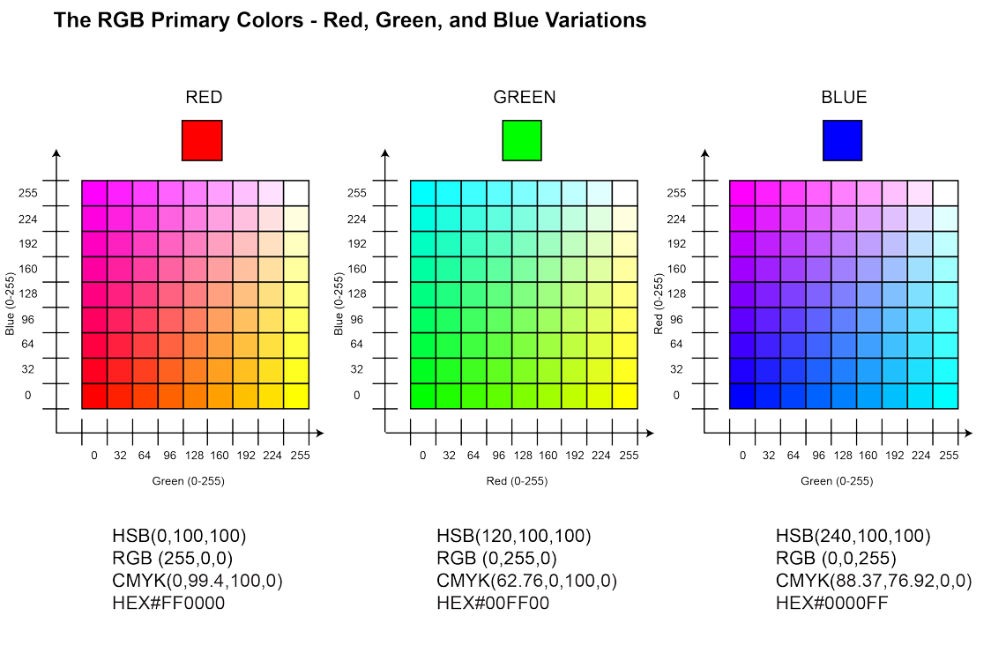
Figure 17 - The RGB Primary Colours [33]

2.The image is divided into 8 x 8 blocks of pixel size in the second step.
To make calculations easier, the number 128 is added to each member of the resulting matrices in the order specified above. This allows us to generate a matrix where all parts are within a specific range (-128 to 127). [33]
[33] (Rishab2612, 2016c)
3.A discrete two-dimensional cosine transform (DCT) is computed for each block.
The distribution of DCT coefficients
In a project I worked on, DCT was one of the essential parts. However, I found it hard to understand because a lot of it was math equations that changed data through graphs.

Testing results

I experienced issues with the application and execution of Benford's Law at the start of the project.

I utilised libraries to convert images and graph the results.
The picture below serves as a reminder of the outcomes I obtained after launching the application.
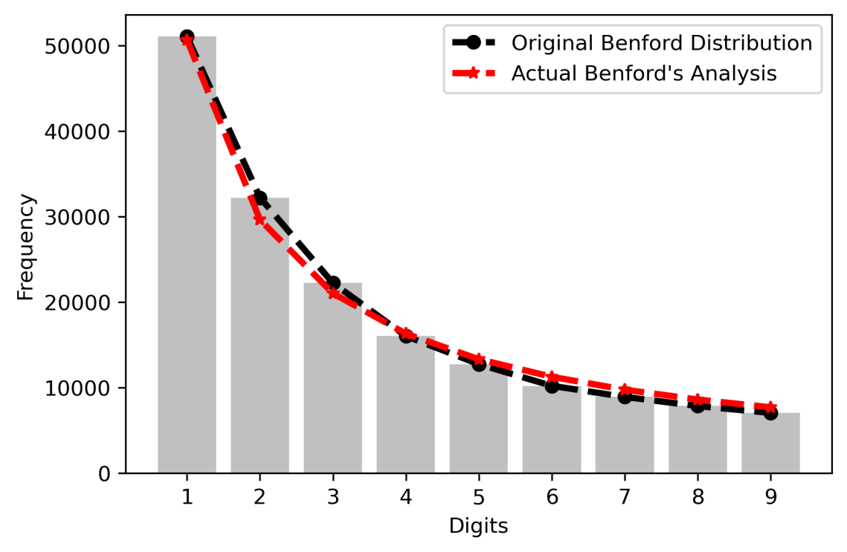

Figure 18 - The first result

So I shifted my thinking and used the formula to perform a computation.

The efficiency of testing increased greatly after this update and the start of testing on my sample pictures.
Significantly, I mean that the impacts can be seen on the charts as well as in numerical form, but they are not a clear conclusion that allows me to say a fake or a fake.

Findings on this matter are enclosed in my conclusions on this project as well as on its operation.
I've included some findings obtained using the new method of testing and computing Benford's law in the section below.
So, this is original picture before any modification and its result below
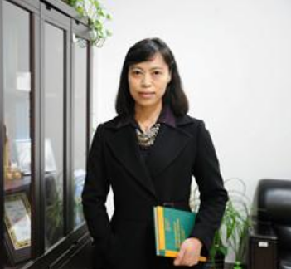
Figure 19 - Original picture and it’s tests result
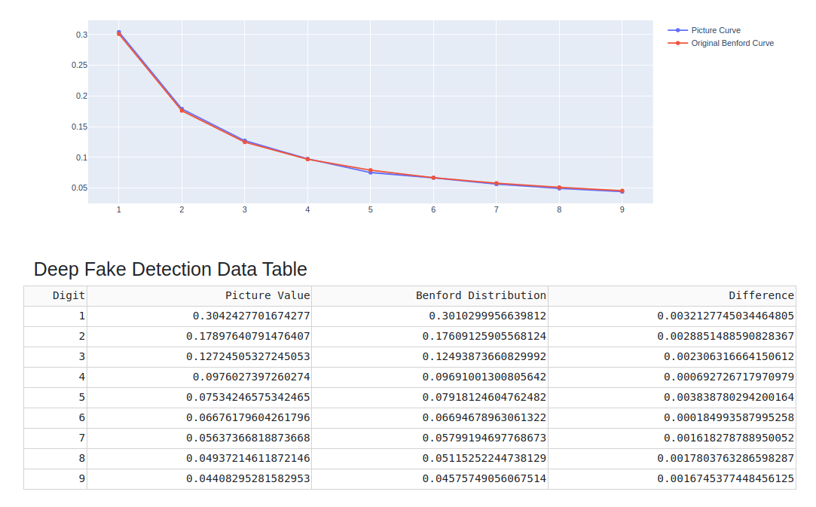

This is the same picture after modification ant it’s result below.
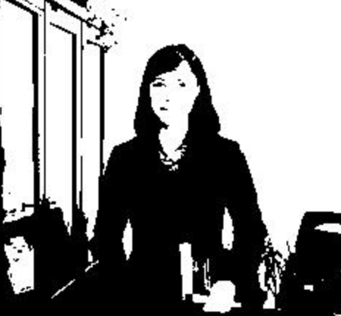
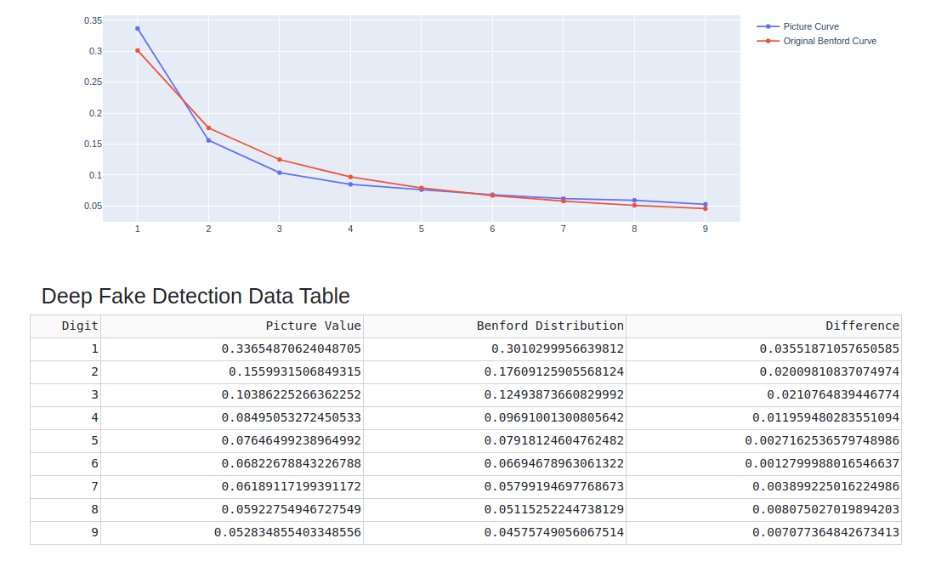
Figure 20 - Altered picture and it’s tests result

It is possible to observe discrepancies in this graph, as well as differences in the numerical table for
confirmation, where the discrepancy is very evident.

Example
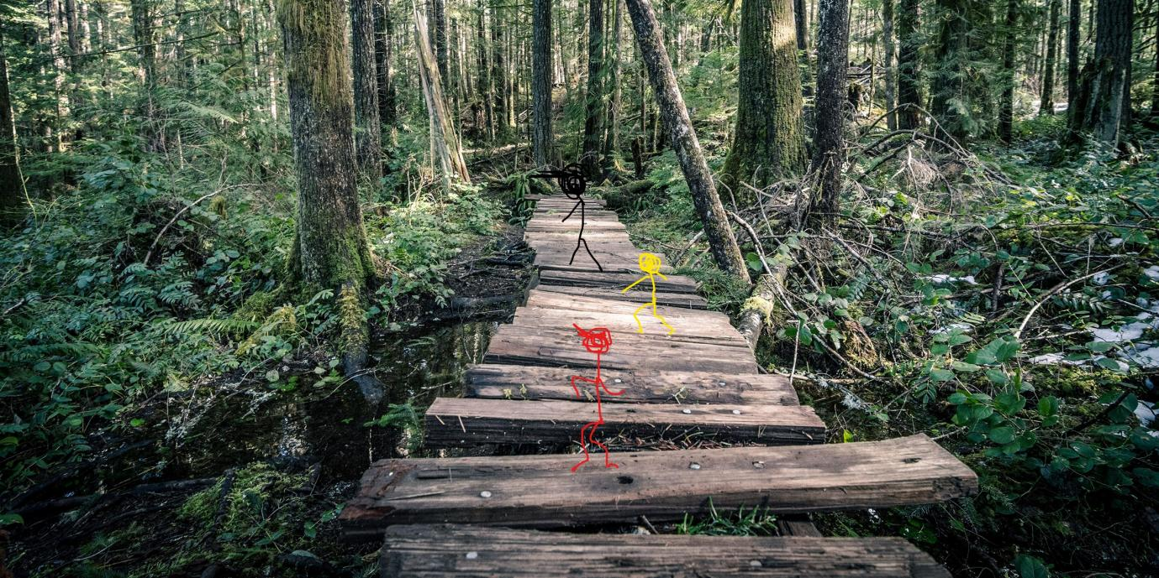
Figure 21 - Picture with little modification and it’s tests result
A little modification does not show discrepancies.

Testing result below:

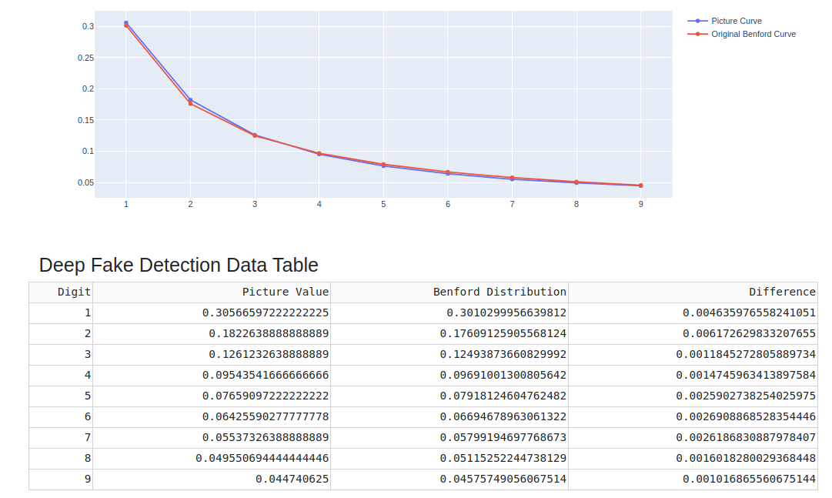
End edited picture below:
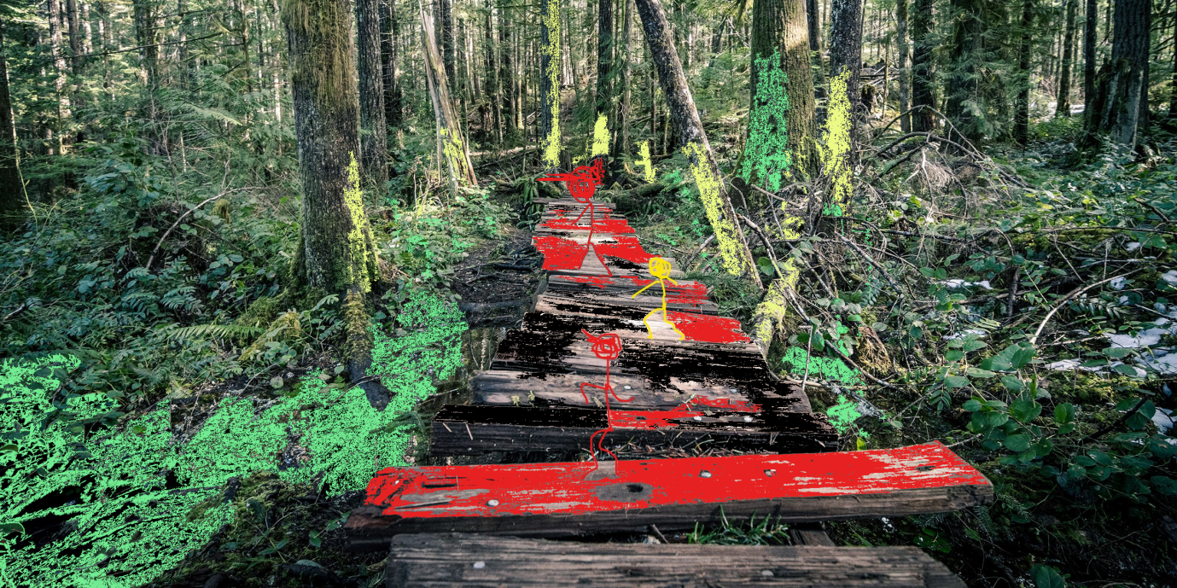
Figure 22- Altered picture and it’s tests result
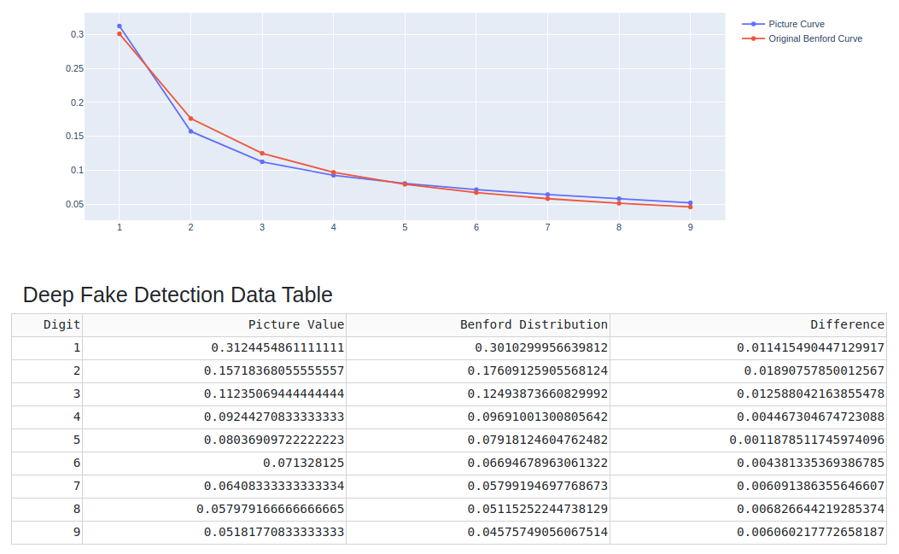

Sometimes, there are significant differences in the photos that were evaluated. However, there are situations when the discrepancies are so minimal that it is impossible to tell if something has been altered or it doesn't.
See examples below.
Figure 23 - State of Art and it’s tests result

You can clearly see the discrepancies here
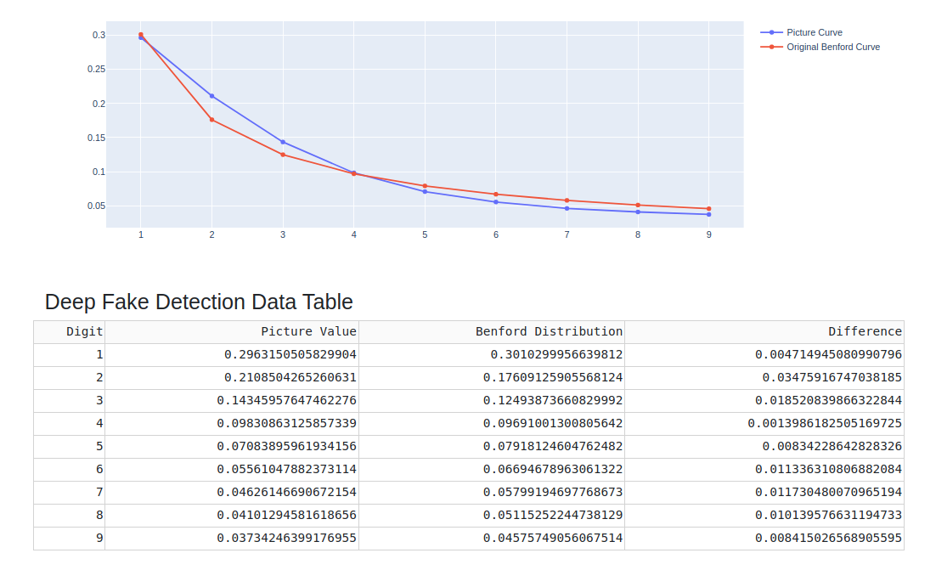

Next example here:

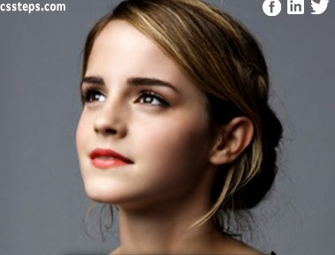

Figure 24 - Deepfake picture and it’s tests result

This picture is deepfake for 100 %
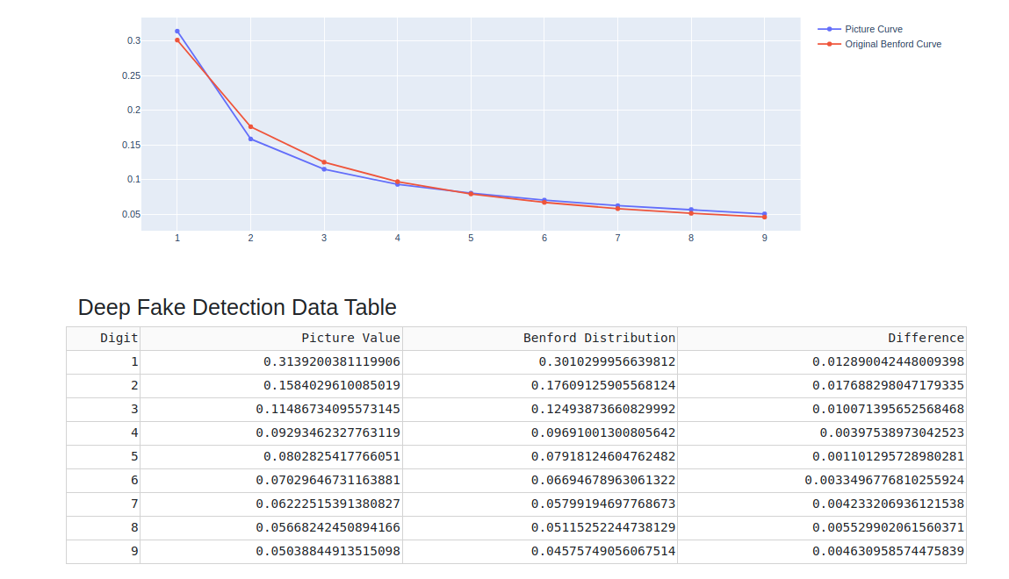

But the difference is more noticeable in the numbers than in the chart.

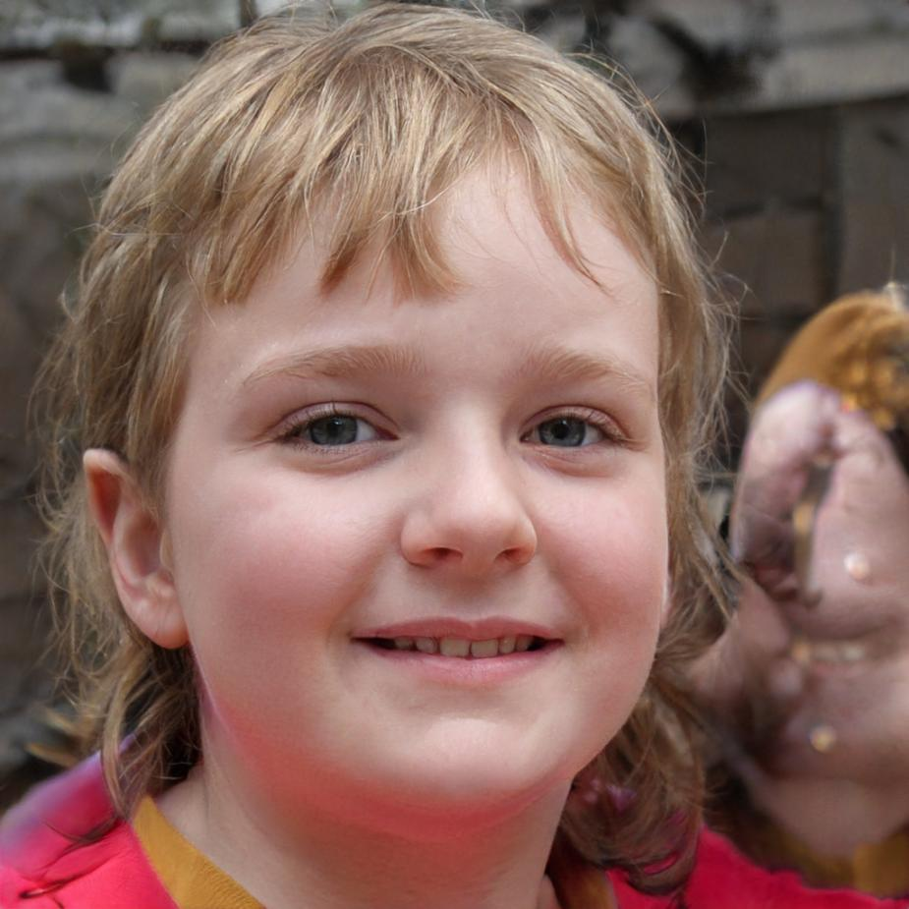

Figure 25 - Deepfake picture and it’s tests result
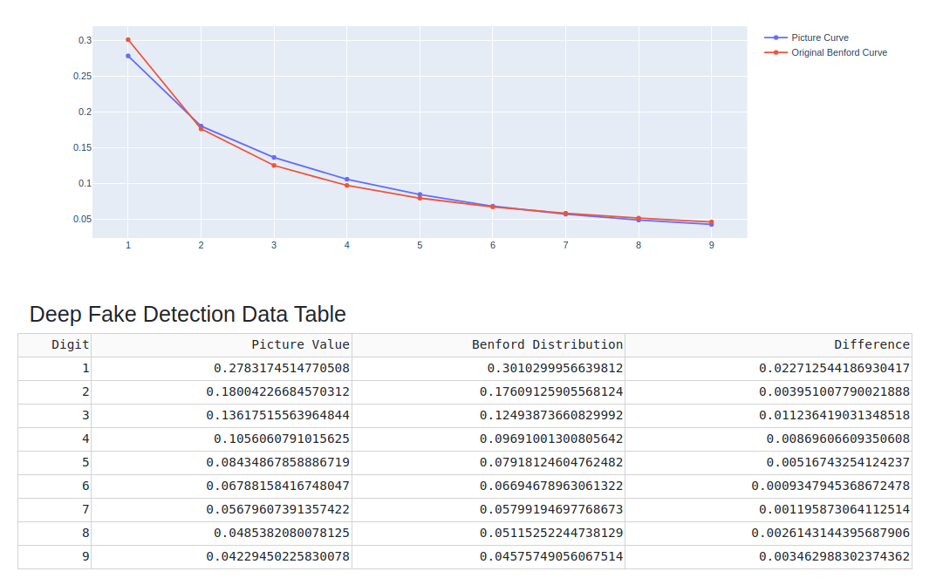
This kid image was digitally generated – kid doesn’t exist. And this is the result of testing:

And once more. You can see the differences, but does the presented result give you complete certainty that there were some manipulations with this photo?
I wouldn't be so sure.

Technologies for the Project
When discussing the relationship between Benford's Law and JPEG file compression, it's important to note that they are not mutually exclusive.
File compression provides a great collection of data because of its nature and its method.
Python can be used to look for possible violations of this rule.
Python looks like a good development environment for this project because it has a lot of tools and databases.
It has a plethora of mathematical libraries and resources, such as Benford's Law. [38]
[38] (Mata, n.d.)
It is possible to put the functionality of my tool into a web application, so it can be used on any computer and in any language.
You may use the Flask framework to design and create this website. [39]
Developed by Armin Ronacher in 2010, Flask is a Python web platform with a minimal core and an easy-to-extend philosophy that became the most popular Python platform in 2018. [40]
[39] (flask.palletsprojects.com, n.d.)
[40] (says, 2021)

The Flask code library provides common principles for constructing dependable, scalable, and easy-to-maintain web applications to speed up and simplify web application development. The usage of an existing web framework has become the norm in web development projects since the turn of the century, with rare exceptions. Django, ASP.NET, Laravel, and Ruby on Rails are also prominent web frameworks, as is Flask.
Web frameworks provide code functionality or extensions to operate web applications daily.
These are some of the joint operations:
• Routing of URIs
• Validation and assistance with input forms
• The template engine outputs HTML, XML, and other formats in various formats. ORM) stands for object-relational mapping, and it is used to connect to databases and manipulate data.
• Attacks like cross-site scripting (XSS), SQL injection, and other types of inter-site request forgery (CSRF) are protected by this.
• Sessions are saved and retrieved using this technology. [39]
[39] (flask.palletsprojects.com, n.d.)
A web framework like Flask is not a programming language for web development. It is for this reason that the Flask framework requires Python files.

Deepfake solutions as an alternative

Deepfake has been a problem for a long time, and it doesn't appear to be getting any easier. As a result, the message would be apparent. At first glance, an image's originality can be determined. You may focus on the technology that's becoming increasingly important in the realm of file authentication, whether it's for images, artwork, or something else entirely.

Conclusion

Overall, I'm happy with my design. I used the DCT and Benford's Law. DCT is a function that can be used in many ways. There are many types and different versions of it. It was hard to find information on what kind of D.C. was used, but most of the time, it talked about MATLAB and how it was used in their software. If you don't change anything else, I'm happy with how the GUI works. I don't think it was possible to make it faster.
I would not trust the test results 100% if they were done one-on-one. So you can say that the results don't have all of the certainty you need for this kind of goal. But I'm not saying they aren't correct.
This tool can be handy as one of many tools to see if an image has been changed.

Plagiarism Detection

I declare that all material in this submission is entirely my own work except where duly acknowledged. I have cited the sources of all quotations, paraphrases, summaries of information, tables, diagrams or other material; including software and other electronic media in which intellectual property rights may reside.
I have provided a complete bibliography of all works and sources used in the preparation of this submission. I understand that failure to comply with the Institute’s regulations governing plagiarism constitute a serious offence.

Student Name: Marcin Kaczmarek
Student Number: C00242533
Date: 12/04/2022

Table of Figures
Figure 1- Deepfake Example 3
Figure 2- Simon Newcomb and Frank Benford 6
Figure 3- "Benford’s Law | Brilliant Math & Science Wiki”2019) 9
Figure 4- JPEG example image 16
Figure 5 - PNG example image 18
Figure 6 - GIF example image 19
Figure 7 - TIFF example image 20
Figure 8 - RAW example image 21
Figure 9 - Compression steps 23
Figure 10 - 8x8 matrix [34] 23
Figure 11 - Zig-Zag method [35] 24
Figure 12 - DCT Quantization [ 35] 24
Figure 13 - Original picture example [36] 25
Figure 14 - Picture during DCT processing [36] 25
Figure 15 - Quantised DCT of the picture. [36] 25
Figure 16 - Original and processed image [37] 26
Figure 17 - The RGB Primary Colours [33] 27
Figure 18 - The first result 28
Figure 19 - Original picture and it’s tests result 29
Figure 20 - Altered picture and it’s tests result 30
Figure 21 - Picture with little modification and it’s tests result 31
Figure 22- Altered picture and it’s tests result 32
Figure 23 - State of Art and it’s tests result 33
Figure 24 - Deepfake picture and it’s tests result 34
Figure 25 - Deepfake picture and it’s tests result 35

Table of Tables
Table 1 Distribution of leading digits 7
Table 2 Benford Law Distribution 10
Table 3 The digit frequency predicted by the equation 11
Table 4 Accounting fraud example [18] (Invest Excel, 2012b) 13
Table 5 A Summary of Image Formats 21

References
[1]
Botticello, C. (2020). What is a Deepfake? [online] Deepfake. Available at: https://medium.com/deepfake/what-is-a-deepfake-9bcc72f3eb1e [Accessed 25 Nov. 2021].
[2]
ScreenRant. (2020). How Deepfake Technology Works. [online] Available at: https://screenrant.com/deepfake-videos-explained-how/ [Accessed 25 Nov. 2021].
[3]
PenTestIT. (2020b). List of Open Source Deepfake Detection Tools. [online] Available at: https://pentestit.com/open-source-deepfake-detection-tool-list/ [Accessed 25 Nov. 2021].
[4]
Yu, P., Xia, Z., Fei, J. and Lu, Y. (2021). A Survey on Deepfake Video Detection. IET Biometrics. / [Accessed 26 Nov. 2021].
[5]
us.norton.com. (n.d.). How to spot deepfake videos — 15 signs to watch for. [online] Available at: https://us.norton.com/internetsecurity-emerging-threats-how-to-spot-deepfakes.html. / [Accessed 26 Nov. 2021].
[6]
DeepQuanty. (n.d.). Sherlock AI. [online] Available at: http://deepquantyailabs.com/sherlock-ai/ [Accessed 25 Nov. 2021].
[7]
Du, L., Chen, Z. and Ke, Y. (2018). Image Hashing for Tamper Detection with Multiview Embedding and Perceptual Saliency. Advances in Multimedia, [online] 2018, p.e4235268. Available at: https://www.hindawi.com/journals/am/2018/4235268/ [Accessed 25 Nov. 2021].
[8]
Locklizard. (2015). Document Watermarks: Digital Watermarking Security for Documents, Files - Locklizard. [online] Available at: https://www.locklizard.com/document-watermarking/ / [Accessed 26 Nov. 2021].
[9]
Gonsalves, R.A. (2020). Benford's Law — A Simple Explanation. Medium. [online] 6 Oct. Available at: https://towardsdatascience.com/benfords-law-a-simple-explanation-341e17abbe75. / [Accessed 26 Nov. 2021].
[10]
Gizmodo. (n.d.). Stigler's Law: Why nothing in science is ever named after its actual discoverer. [online] Available at: https://gizmodo.com/stiglers-law-why-nothing-in-science-is-ever-named-afte-5820736 [Accessed 25 Nov. 2021].
[11]
Research & Development World. (2015). How a Simple Observation from the 1800s about Patterns in Big Data Sets Can Fight Fraud. [online] Available at: https://www.rdworldonline.com/how-a-simple-observation-from-the-1800s-about-patterns-in-big-data-sets-can-fight-fraud/ [Accessed 25 Nov. 2021].
[12]
Labs, Fsp. (2016). Forensics and Benford's Law. [online] Event Log Explorer blog. Available at: https://eventlogxp.com/blog/forensics-and-benfords-law/ [Accessed 25 Nov. 2021].
[13]
Invest Excel. (2012a). Find Financial Fraud with Benford's Law. [online] Available at: https://investexcel.net/benfords-law-excel [Accessed 25 Nov. 2021].
[14]
Anon, (n.d.). [online] Available at: https://www.acfe.com/uploadedFiles/Shared_Content/Products/Self-Study_CPE/UsingBenfordsLaw_2018_final_extract.pdf [Accessed 26 Nov. 2021].
[15]
Amiram, D., Bozanic, Z. and Rouen, E. (2015). Financial statement errors: evidence from the distributional properties of financial statement numbers. Review of Accounting Studies, 20(4), pp.1540–1593. / [Accessed 26 Nov. 2021].
[16]
Durtschi, D., Hillison, W. and Pacini, C. (n.d.). The Effective Use of Benford's Law to Assist in Detecting Fraud in Accounting Data. [online] Available at: https://www.researchgate.net/publication/241401706_The_Effective_Use_of_Benford’s_Law_to_Assist_in_Detecting_Fraud_in_Accounting_Data [Accessed 26 Nov. 2021].
[17]
Browne, M. (1998). Following Benford's Law, or Looking Out for No. 1. [online] Available at: https://people.math.harvard.edu/~ctm/home/text/class/harvard/154/11/html/media/benfords_law.pdf [Accessed 26 Nov. 2021].
[18]
Invest Excel. (2012). Find Financial Fraud with Benford's Law. [online] Available at: https://investexcel.net/benfords-law-excel/ [Accessed 26 Nov. 2021].
[19]
Roukema, B.F. (2013). A first-digit anomaly in the 2009 Iranian presidential election. Journal of Applied Statistics, 41(1), pp.164–199. / [Accessed 26 Nov. 2021].
[20]
Westerlund, M. (2019). The Emergence of Deepfake Technology: A Review. Technology Innovation Management Review, [online] 9(11). Available at: https://timreview.ca/article/1282. / [Accessed 26 Nov. 2021].
[21]
Anon, (n.d.). Detecting Photoshopped Faces by Scripting Photoshop. [online] Available at: https://arxiv.org/pdf/1906.05856.pdf [Accessed 26 Nov. 2021].
[22]
PenTestIT. (2020). Deepstar: An Open Source Deepfake Detection Toolkit. [online] Available at: https://pentestit.com/deepstar-open-source-deepfake-detection-toolkit/ [Accessed 26 Nov. 2021].
[23]
Jemine, C. (n.d.). Resemblyzer 0.1.1.dev0: Analyse and compare voices with deep learning. [online] PyPI. Available at: https://pypi.org/project/Resemblyzer/ [Accessed 26 Nov. 2021].
[24]
Iqbal, K. (2019a). JPEG - Image File Format. [online] docs.fileformat.com. Available at: https://docs.fileformat.com/image/jpeg [Accessed 26 Nov. 2021].
[25]
Rishab2612 (2016a). Comparison between JPEG(DCT) and JPEG 2000(DWT) compression standards. [online] Available at: https://www.slideshare.net/Rishab2612/comparison-between-jpegdct-and-jpeg-2000dwt-compression-standards [Accessed 26 Nov. 2021].
[26]
FixThePhoto.com. (n.d.). What Is Highest Quality Image Format? [online] Available at: https://fixthephoto.com/highest-quality-image-format.html. / [Accessed 26 Nov. 2021].
[27]
DISCRETE COSINE TRANSFORM DISCRETE COSINE TRANSFORM FOR VARIOUS VALUES OF U AND V. (n.d.). [online] Available at: https://d1b10bmlvqabco.cloudfront.net/attach/iizifk1n4713c/idqzrrsbms75iv/inczelhjcc5k/image_seminars.pdf [Accessed 26 Nov. 2021].
[28]
W3.org. (2019). Portable Network Graphics (PNG) Specification (Second Edition). [online] Available at: https://www.w3.org/TR/2003/REC-PNG-20031110/./ [Accessed 26 Nov. 2021].
[29]
Ayres, C. (2017). 6 Advantages and Disadvantages of Animated Gifs. [online] ConnectUS. Available at: https://connectusfund.org/6-advantages-and-disadvantages-of-animated-gifs. / [Accessed 26 Nov. 2021].
[30]
Iqbal, K. (2019). TIFF - Image File Format. [online] docs.fileformat.com. Available at: https://docs.fileformat.com/image/tiff [Accessed 26 Nov. 2021].
[31]
dpbestflow.org. (n.d.). Raw File Formats | dpBestflow. [online] Available at: https://dpbestflow.org/file-format/raw-file-formats [Accessed 26 Nov. 2021].
[32]
unix4lyfe.org. (n.d.). Discrete Cosine Transform. [online] Available at: https://unix4lyfe.org/dct-1d [Accessed 26 Nov. 2021].
[33]
Rishab2612 (2016a). Comparison between JPEG(DCT) and JPEG 2000(DWT) compression standards. [online] Available at: https://www.slideshare.net/Rishab2612/comparison-between-jpegdct-and-jpeg-2000dwt-compression-standards. / [Accessed 26 Nov. 2021].
[34]
Scribd. (n.d.). DCT | PDF | Data Compression | Matrix (Mathematics). [online] Available at: https://www.scribd.com/document/79004855/dct [Accessed 26 Nov. 2021].
[35]
M, A.K. (2016). JPEG Image Compression. [online] Slideshare.net. Available at: https://www.slideshare.net/AishwaryaKM1/jpeg-image-compression-56894348. / [Accessed 26 Nov. 2021].
[36]
Anon, (n.d.). ,PDJH &RPSUHVVLRQ DQG WKH 'LVFUHWH &RVLQH 7UDQVIRUP. [online] Available at: https://www.math.cuhk.edu.hk/~lmlui/dct.pdf [Accessed 26 Nov. 2021].
[37]
Syed, A. and Khayam (2003). The Discrete Cosine Transform (DCT): Theory and Application 1. [online] Available at: https://www.egr.msu.edu/waves/people/Ali_files/DCT_TR802.pdf. / [Accessed 26 Nov. 2021].
[38]
Mata, R. (n.d.). benford-law: A python tool to calculate the Benford's Law from a dataset or image. [online] PyPI. Available at: https://pypi.org/project/benford-law/ [Accessed 26 Nov. 2021].
[39]
flask.palletsprojects.com. (n.d.). Welcome to Flask — Flask Documentation (2.0.x). [online] Available at: https://flask.palletsprojects.com/en/2.0.x/./ [Accessed 26 Nov. 2021].
[40]
“Benford’s Law | Brilliant Math & Science Wiki.” Brilliant.org, 2019, brilliant.org/wiki/benfords-law/.

